Name:
Date:

VISUAL COMMUNICATION TOUCHSTONE 3 ASSIGNMENT QUESTIONS

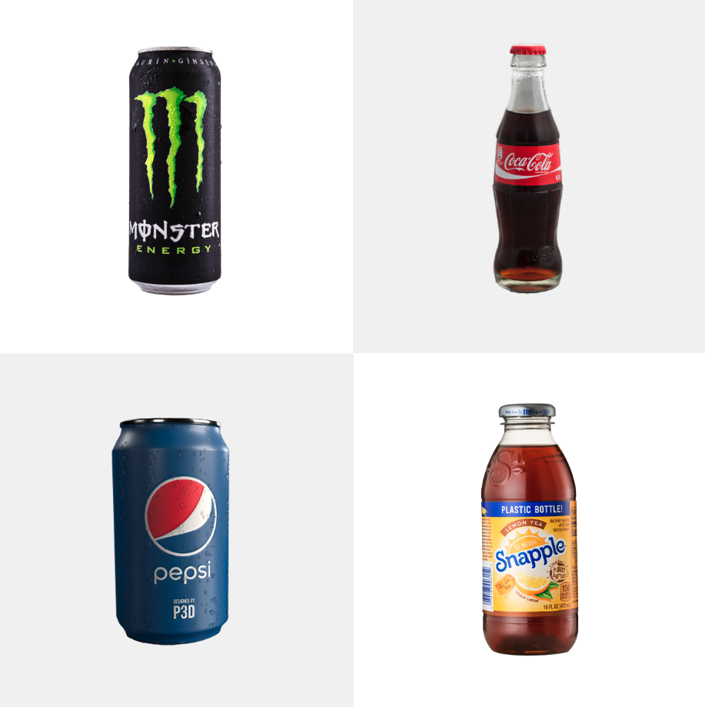
PLEASE LIST YOUR TWO CHOSEN BRANDS HERE:

1. Pepsi
2. Monster

Question 1: Basics of Visual Design Concepts

Analyze the two logos and explain how both designs employ visual communication aspects to attract consumers. Write a 200-word response that compares the logos’ use of at least two of the following: Semiotics, Visual Communication Psychology, Cognitive Theory, and or other applicable Visual Communication Theories as discussed in Unit 1.1, Vision and Interpretation. Your response must indicate your two choices from those listed above in bold and include substantive information on each. Use in-text citations if borrowing information from the course materials. No outside sources should be used.

Question 2: Elements of Design

Analyze the visual elements that two of the current brand logos use in their designs, such as color schemes, shape, space, size, line, and texture. Write a 200-word response explaining how the visual elements are used in each brand design as discussed in Unit 1.2, the Elements of Design. Your response must indicate your two choices from those listed above in bold and include substantive information about each. Use in-text citations if borrowing information from the course materials. No outside sources should be used.

Question 3: Principles and Elements of Visual Design

Analyze the design principles that the two brands use in their logos and how they adhere to balance, contrast, emphasis, movement, pattern, rhythm, and unity as discussed in Unit 1.3, Principles of Visual Design, and in Unit 2.1, Color. Write a 200-word minimum response explaining how at least two of those principles are applied in the logos’ designs. Your response must indicate your two choices from those listed above in bold and include substantive information about each. Use in-text citations if borrowing information from the course materials. No outside sources should be used.

Question 4: Typography, Design and Layout

Analyze the use of typography and layout practices that both brands use in their logos. Write a 200-word response that explains how they adhere to at least two of the following: type choices, alignment, layout styles, visual hierarchy, or other layout principles as discussed in Units 2.2 and 2.3, Typography and Layout. Your response must indicate your two choices from those listed in bold above and include substantive information about each. Use in-text citations if borrowing information from the course materials. No outside sources should be used.

Question 5: Role of Visual Design in Communication

Propose how your UX/UI team should use Ideation and Visual Thinking, Storytelling, and Inspiration as discussed in Unit 3.1, Creative Process to build a logo for Bad Apples Cider Company. Consider how the company’s name can be represented visually, and how your team could apply at least two of the concepts listed in bold above to build a logo that successfully communicates with consumers. Your 200-word response must indicate your two choices and include substantive information about each. Use in-text citations if borrowing information from the course materials. No outside sources should be used.

Question 6: Influence of Visual Design

Explain at least three ways that Bad Apples Cider Company can use Visual Design in Advertising, Public Relations, Infographics, and Publishing as discussed in Unit 3.2, the Influence of Visual Design. Keep in mind brand consistency and how other design factors like images and color play a role in visual communication. Your 200-word response must clearly indicate your three choices from those listed in bold above and include substantive information about each. Use in-text citations if borrowing information from the course materials. No outside sources should be used.

Image Attributions:
Coca-Cola bottle | Author: Ralf Roletschek | License: Public domain
Pepsi can | Author: Priyam Patel | License: Public domain

